OSH ALERT 2019-03 [30 January 2019]

Electronic Filing of CY 2018 OSHA I&I Data

Employers are reminded that March 2, 2019 is the deadline date for the electronic submission of CY 2018 Injury & Illness data (the data appearing on the completed OSHA Form 300A Summary).

Guidance in re how such data is transferred to OSHA can be found by following this link:

https://www.osha.gov/injuryreporting/

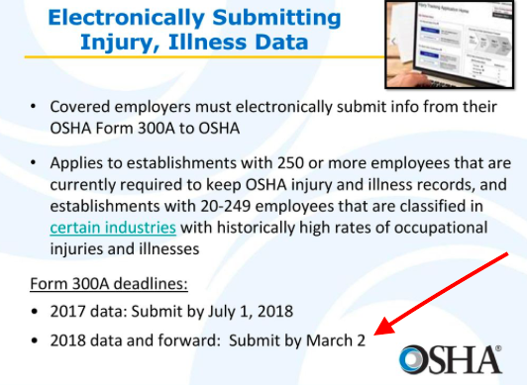

Got a question about this particular subject? Write to the JSC at: blueoceana@optonline.net

